

**Department of Computer Science and Engineering**

| **Course Code: CSE 423** | **Credits: 1.5** |
| --- | --- |
| **Course Name: Computer Graphics** | **Semester: Fall 23** |

**Lab 03**

**Midpoint Circle Drawing Algorithm**

**I. Topic Overview:**

The students were introduced to the Midpoint line drawing algorithm in the previous class. Given the coordinates of any two points on the line: (x1, y1) & (x2, y2), the student’s task was to find all the intermediate points required for drawing the line on the computer screen of pixels where every pixel has integer coordinates.

Today, we would be introducing a similar approach to draw a circle. This algorithm tries to find the best approximation of the next point on the circle using a decision parameter. As we will only choose one between two pixels as we did previously in the midpoint line drawing algorithm it will be a quite fast approach.

We would be drawing a part of the circle, let's say only zone 0. The students might think that they might have to generate 8 different equations for eight different zones. However, we will be applying the 8-way symmetry approach to draw the portion of the circle for the rest of the zones.

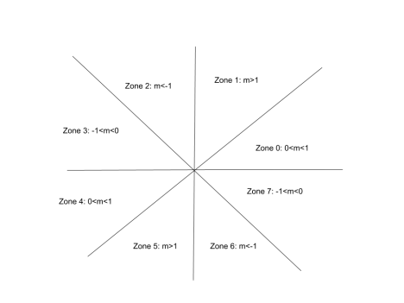

**II. Lesson Fit:**

a. Implementation of Midpoint circle drawing algorithm using 8-way symmetry. b. The students should have a clear understanding of the 8-way symmetry approach. c. They should also have a clear idea about all the different zones.

**III. Learning Outcome:**

After this lecture, the students will be able to:

a. Learn how to use a decision parameter to determine the next pixel on the circle. b. Learning how an 8-way symmetry approach naturally helps to draw a circle.

**IV. Anticipated Challenges and Possible Solutions**

Students might get confused about why and how we are using the 8-way symmetry approach.

**Solutions:**

Students should understand why and how we are drawing a point of a particular point to another zone and in which zone the calculations are being done for drawing the circle.

**V. Acceptance and Evaluation**

Students will start implementing the algorithm after we finish our lecture. If a student fails to complete the implementation he/she will have to complete it by that night and show it to the class teacher during his/her consultation period. If a student also fails to do that then instead of 10 we will evaluate the student on 7.

1. Lab evaluation marks: **out of 10**

1. **Midpoint Circle implementation: 50% mark**
2. **Activity task: 50% mark**
3. **No mark will be awarded in the activity task if the midpoint circle drawing algorithm is not followed.**

2. Late Lab evaluation marks: **out of 7**

**VI. Activity Detail**

a. **Hour 1:**

**Discussion:**

A circle is defined as a set of points that are all at a given distance r from a center positioned at (xc,yc).

So, the equation of circle according to the center (xc,yc) is,

(*x* − *xc*)2 +( *y* − *yc* )2 = *r*2 ………………. 1

from equation 1 we get the value of y as below,

*y* = *yc* ± √*r*2 − ( − *xc*2  *x* ) ……………….. 2

As *f*(*x*, *y*) = 0 represents a circle, Let,

*f*(*x*, *y*) = (*x* − *xc*) *y* ) …….. 3 2 + ( − *yc*2 − *r*2

Now, for any point,

*f*(*x*, *y*) = 0 , the point is on the circle

*f*(*x*, *y*) > 0 **,** the point is outside the circle

*f*(*x*, *y*) < 0 **,** the point is inside the circle

In the midpoint circle drawing algorithm at each of the ith steps we will be evaluating the circle function to come to a decision. Let us assume that we are giving unit increments to x in the plotting process and determining the y position using this algorithm. Assuming we have just plotted the ith pixel at (xi,yi), we next need to determine whether the pixel at the position (xi+1,yi) or the one at (xi,yi+1) is closer to the circle.

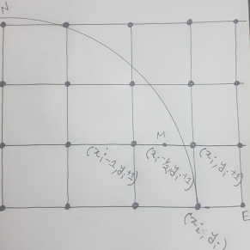

Our decision parameter di at the ith step is the circle function evaluated at the midpoint of these two pixels. The coordinates of the midpoint of these two pixels *i* − 21 *yi* + 1

is (*x* , ) .

Hence, *d* (*x* , ) *x* ) *y* ) …………….. 4 *i* = *fi* − 21 *yi* + 1 = (*i* − 21 2 + (*i* + 12 − *r*2

Successive decision parameters are obtained using incremental calculations, thus avoiding a lot of computation at each step. We obtain a recursive expression for the next decision parameter.

*i*+1 = *fi*+1 − 21 *yi*+1 + 1 = (*i*+1 − 21 2 + (*i* + 1 + 12 − *r*2

Therefore, *d* (*x* , ) *x* ) *y* ) *d x* ) *y* ) ……………………….. 5 *i*+1 = (*i*+1 − 21 2 + (*i* + 22 − *r*2 Now we get by subtracting eqn (4) from eqn (5)

Δ*d* = *di*+1 − *di*

*i*+1 − 21 2 − (*i* − 21 2 + (*i* + 22 − (*i* + 12 − *r*2 + *r*2

Δ*d* = (*x* ) *x* ) *y* ) *y* )

Δ*d* = (*x* ).(*x* ) *y* ……………………. 6 *i*+1 + *xi* − 1 *i*+1 − *xi* + 2 *i* + 3 Now if *d* = , then the midpoint of the two possible pixels lies within the circle, *i* < 0 thus the north pixel is nearer to the theoretical circle.

Hence, *x* . Substituting this value of in eqn (6), we get, *i*+1 = *xi* Δ*d* = *d x* ).(*x* ) *y i*+1 − *di* = (*i* + *xi* − 1 *i* − *xi* + 2 *i* + 3

*d x* ).0 *y i*+1 − *di* = (*i* + *xi* − 1 + 2 *i* + 3

*d y i*+1 = *di* + 2 *i* + 3

And if we consider *d* then, the midpoint of the two possible pixels lies *i* > 0 outside the circle, so the north west pixel is nearer to the theoretical circle. Therefore, *x* . Substituting this value of in eqn (6), we get, *i*+1 = *xi* − 1 Δ*d* = *d x* ).(*x* ) *y i*+1 − *di* = (*i* − 1 + *xi* − 1 *i* − 1 − *xi* + 2 *i* + 3

*d* 2*x* ).(− ) *y i*+1 − *di* = (*i* − 2 1 + 2 *i* + 3

*d x y i*+1 = *di* − 2 *i* + 2 + 2 *i* + 3

*d x y i*+1 = *di* − 2 *i* + 2 *i* + 5

For the initial decision parameter *x* = *r*, *y* = 0 . So, from eqn (4) we get, *d r* ) 0 ) 0 = ( − 21 2 + ( + 12 − *r*2

*d*0 = 45 − *r*

To get the integer value of pixel coordinates, we approximate,

*d* …………………………………………………. 7 0 = 1 − *r*

b. **Hour: 2**

**Discussion: 8-way Symmetry**

Today we will go through the 8-way symmetry approach and we will discuss how we can apply this approach to draw a circle easily.

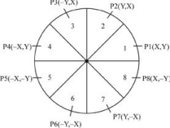

c. **Hour: 3**

**Discussion: Implementation**

Now we will be implementing the midpoint circle algorithm in the lab.

**VII. Home task:**

The whole display screen is going to act as a water body while following functionalities that are given below:

1. Clicking on the **right button** of a mouse will generate a small circle and the center point of the circle should be where the right button click will be given in the display screen. Depending on the **number of clicks** of the right button of the mouse, that **many circles will appear**.

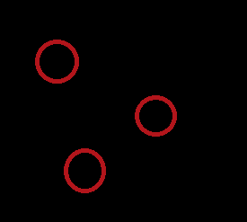

1. The circles generated will eventually **grow in size** meaning the radius of the circle(s) will increase overtime.

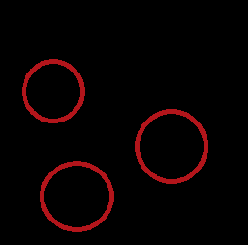

1. A circle will stay on screen and its size will increase overtime up until the whole circle **can not fully fit** inside the display window. Meaning that if the circle **boundary touches or goes beyond the display boundary**, that particular circle will be erased from the display for good. Do not keep any reference/data/object of the circle that has been gone out of display, your code must delete it from memory.



**Here two of the three circles disappeared because their boundary either touched/crossed the boundary of the display screen.**

1. Clicking on the **space button** will pause the process and no new circles can be created when it is paused. Again clicking the space button when the process is paused will resume the process.
2. Pressing **Left arrow** will make the circle grow faster and the **right arrow** will make the circle grow slower.

**[hint:** Considering that the coordinate value of the lower left corner of the screen is (0,0), let's say the coordinates of the center point of a circle is (a,b) and its radius is r. Then, the circle will fully fit inside the display screen if *xMIN* < (a-r) and (a+r) < *xMAX*  and *yMIN* < (b-r) and (b+r) < *yMAX* .**]**